**USE OF BLUEBIRD NEST BOXES AT**

**THE PHILLIP SCHNEIDER WILDLIFE AREA, 1990 - 2019**

Charlotte C. Corkran, Northwest Ecological Research Institute

Research Report #20-02

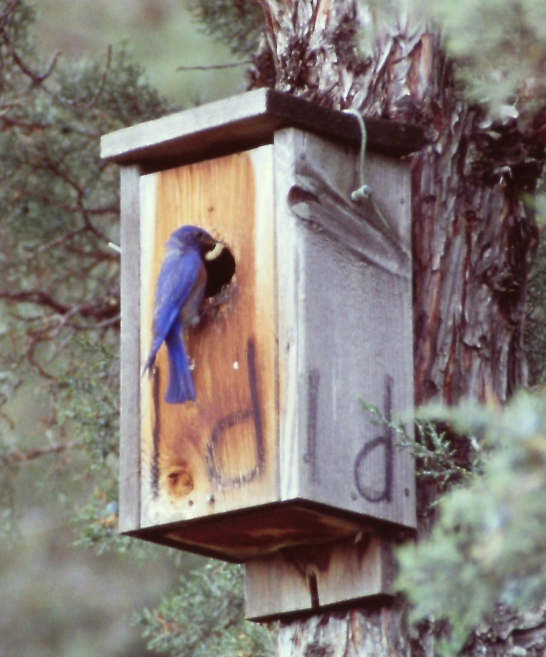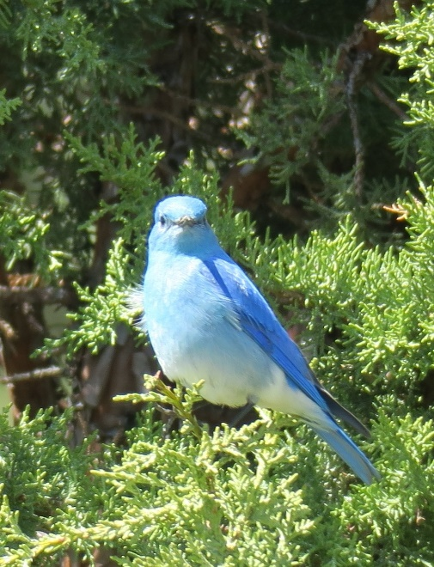

Western Bluebird male at nest box Mountain Bluebird male

As part of a study of Western and Mountain Bluebirds (*Sialia mexicana* and *S. currucoides*) in central Oregon, nest boxes were placed on the Oregon Department of Fish and Wildlife’s (ODFW) Phillip Schneider Wildlife Area (PSWA) in Grant County, formerly called Murderers Creek Wildlife Management Area. This report briefly describes the study and summarizes the use of the nest boxes at PSWA by bluebirds and other birds since the boxes were put up there in 1989. The study and nest box monitoring are a project of the Northwest Ecological Research Institute, a small non-profit organization based in Portland and conducting natural history research and education in Oregon and Washington.

OBJECTIVES – The original objective of the bluebird study was to investigate potential impacts of large-scale spraying with Malathion to suppress infestations of grasshoppers in Wheeler County. No spray program was carried out in the first few years of the study, and revised environmental regulations limited the scope of potential chemical spray programs, causing the research to be unnecessary. The study then tried to investigate whether bluebird productivity differs between sites that are predominantly native bunchgrass and those that are predominantly introduced annual grasses, particularly Medusahead (*Taeniatherum caput-medusae*) and Cheatgrass (*Bromus tectorum*). However, due to lack of funding for either field work or analysis, the research has been replaced by post-breeding season monitoring of the nest boxes with occasional visits during the nesting season.

STUDY AREAS – In the spring of 1988, eight sites, each with 35 nest boxes, were established on private ranches around the town of Fossil in Wheeler County. Two sites were not productive and were abandoned after a few years. Three other sites were abandoned recently, due to a fire, scaling back our efforts, and a change of land ownership.

At the PSWA, two sites, each with 35 nest boxes, were established on the flats north of Murderers Creek in the fall of 1989 (see Figures 1, 2, and 3-A, 3-B, and 3-C.). These were intended to be control sites to compare with treatment sites in Wheeler County.

At each site, the nest boxes were originally laid out in approximately a grid pattern (modified by terrain). They averaged about 100 meters apart and were attached 1.5 to 2.5 meters high on juniper trees, fence posts, or at PSWA some were attached on poles in rock jacks constructed by high school students volunteering with ODFW.

METHODS – From 1988 (1990 for PSWA) through 1998, all nest boxes were checked 2 to 6 times during the breeding season of April through July, and once in October for final cleaning and repairs. We often missed the beginning and ending of the breeding season, and were rarely able to observe the nests more frequently than every 12 to 14 days. Since 1999, we have not been able to monitor the boxes during the breeding season in most years.

On each visit, nests were identified to species, if adults were seen, or group (e.g., bluebird, swallow). Number of eggs and/or number and development stage of live or dead nestlings were recorded. Fledged or failed nests were cleaned out of the box, except during the breeding season if adult birds stayed close during our observation, indicating that they might re-nest. In the fall, all boxes were cleaned out.

For several years we also took observational diet samples, using binoculars to identify prey items delivered to nestlings by the parent bluebirds. Both species of bluebird fed a variety of invertebrates, from ants to spiders to dragonflies, but predominantly brought Orthopterans to the nests. Mountain Bluebirds caught more crickets, while Western Bluebirds caught more grasshoppers. However, that difference was partially due to the Mountain Bluebirds initiating nests earlier, when crickets were common but grasshoppers had not yet emerged.

Vegetation at each site was characterized by randomly placing 25-square meter habitat plots, and recording the frequency of occurrence of key grass species and types. In addition, a general grass type and tree density characterization was made at each nest box. These data were not analyzed, partly because at PSWA the ongoing efforts to remove invasive plant species and restore native ones meant that the vegetation has changed repeatedly during the years.

Many nest boxes have been replaced and/or relocated from their original positions. After fires, most dead junipers do not remain standing for long. At unburned sites, juniper encroachment can reduce the desirability of nest boxes to bluebirds. Cattle rub on accessible boxes, often breaking them. Analysis of bluebird productivity associated with localized habitat conditions was not possible after a few years of such changes in habitat and nest box locations.

RESULTS and DISCUSSION – The data we have been able to gather are inconsistent for the several reasons mentioned above, but also due to lack of funding after 1998 for the 600-mile, 3 or 4-day trips from Portland. The majority of data from the bluebird study has not been entered into a database, much less statistically analyzed. Following is a summary of the raw data from PSWA.

The numbers of nest boxes available to birds each year are shown in Table 1. Also shown are the number used each year, and the percent of the total boxes available. This includes only the boxes that had at least one nest of any bird species with at least one egg laid. It does not include the many bird nests or nest starts that never proceeded to the laying of eggs The table does not include evidence of birds roosting in the boxes or of rodent use.

In the first year, only 9 of the 70 boxes (13%) at the PSWA received one or more bird nests with at least one egg laid. Since the 5th year, about half of the boxes are used each year, with a high of 77% in 2000. This rate of usage is less than at our Wheeler County sites, where 24% of the boxes were used the first year, and nearly 75% of the boxes in many years.

Table 1 also shows the number of fledged bluebird nests each year. Estimates are given for each species and for “total bluebirds” which includes the known Western and Mountain Bluebird nests plus unknown bluebirds (those that could not be identified to species). Because we have not been able to monitor the boxes annually during the nesting season since 1998, for the later years most of the bluebird nests could not be distinguished to species. In several years, early nests had already fledged before our first visit. Since Mountain Bluebirds usually initiate nesting two weeks earlier than Western Bluebirds, we probably missed more Mountain than Western Bluebird nest identities.

The table does not include the many bluebird nest failures. The majority of these failures are weather-related. When periods of cold wet weather exceed one or two days, invertebrate prey become scarce or concealed, and many nests full of eggs or nestlings are abandoned. Once the weather improves and prey are available again, the parents often initiate a new nest, sometimes on top of the dead eggs or nestlings. Predation was less frequent than weather failures. Bluebird parents did not start a new nest in the same box after a predation event. In some years, predation by American Kestrels (*Falco sparverius*) was a minor problem. The falcons can hover at the nest box entrance and take bluebird nestlings, especially ones old enough to move to the entrance when they hear a parent approaching, presumably with food. Gopher Snakes (*Pituophis catenifer*) caused a few losses of eggs and nestlings. Deer Mice (*Peromyscus maniculatis*) and possibly other rodents were more apt to scavenge abandoned eggs and dead nestlings than to kill live ones. The mice and probably other rodents usually chewed and refashioned bird nests, and their actions made it very difficult to later determine the fate of many bird nests. In two separate years, we found dead Sagebrush Voles (*Lemmiscus curtatus*) in several of the boxes. Possibly some of the rodent nests we assumed were made by mice were from this species.

The numbers in Table 1 and our incidental observations indicate that Western Bluebirds increased for the first few years but may have then declined, while Mountain Bluebirds started out at lower numbers but have surpassed Western Bluebirds in recent years. This same pattern seems to have occurred at our Wheeler County sites as well. At PSWA, after the first year the boxes were in place, there has been an average of about 23 successfully fledged bluebird nests annually.

Each year all bird species build nests and lay eggs in about 48% or almost half of the nest boxes that are available. Tree Swallows (*Tachycineta bicolor*) and Mountain Chickadees (*Poecile gambeli*) have used one or 2 boxes in many years. Ash-throated Flycatchers (*Myiarchus cinerascens*) began to use a box or 2 after the first few years. In the last 8 years House Wrens (*Troglodytes aedon*) have begun to use the boxes, too. Table 1 only shows the successful nests of these species.

In 1997 we looked at bluebird nest success and productivity in different sections of our study sites on the PSWA. In that year, bluebirds laid slightly more eggs, hatched a greater percentage of eggs, and fledged a greater percentage of eggs in the area that had been repeatedly controlled-burned and then partially ground-treated with herbicide in 1997, as compared to the non-treatment areas where Medusahead still dominated the vegetation. A brief report was prepared for ODFW. Where the invasive grass grew densely, it curled over horizontally, forming a matted layer that apparently prevented bluebirds from easily spotting prey invertebrates on the ground.

The original study ended because insecticide spraying never occurred (and application rules changed). We will analyze all of the bluebird data as limited time permits. However, the analysis of bluebird productivity in predominantly native bunchgrass sites compared with those in predominantly invasive annual grasses may not be possible due to lack of sufficient and consistent data, and to changes in the vegetation because of fires, exotic grass invasion, and native plant restoration efforts.

The PSWA is a rich habitat resource for a diverse assemblage of native wildlife species. During the period 1995 to 1999, we participated in the Oregon Breeding Bird Atlas Project, contributing our incidental findings to the project. Increased effort was spent in searching for nests (or other observations of nesting activity) for all birds, and confirmed additional species breeding on the PSWA by finding active nests of Common Nighthawk (*Chordeiles minor*), Lark Sparrow (*Chondestes grammacus*), Western Meadowlark (*Sturnella neglecta*), and others. In recent years, we have kept track of all birds seen and heard on our visits, submitting checklists to the Cornell Ornithology Lab’s eBird database. We also contributed breeding bird data from the PSWA (but not from our nest box study sites) to the Oregon 2020 Project at Oregon State University.

In the last few years, other nest boxes have been placed on the PSWA than the ones that we put up. We have checked a few of these, and some of our volunteers have cleaned out the ones along their routes, perhaps inadvertently interfering with someone else’s study. We would like to cooperate with other nest box monitors on the PSWA. If there is a school class or scout troop placing nest boxes, we would be happy to come out and talk to the group about cavity-nesting birds, conservation, and nest box construction and placement. Eventually we will need to turn over management of our nest boxes to younger monitors.

We appreciate the interest and cooperation of ODFW and the Bureau of Land Management. The PSWA has been an excellent study site for our research (successful or not), and we intend to continue monitoring bluebirds and other wildlife using the nest boxes and the area.

The data in this report may be inconsistent, but would not have been collected at all without the incredible dedication of The Bluebird Gang: Hal Hushbeck (from 1989 on), Cathy Flick (from 2000 on), Ginny Taylor (1989 - 2002), Margie James, Karl Hartzell, and other occasional helpers.

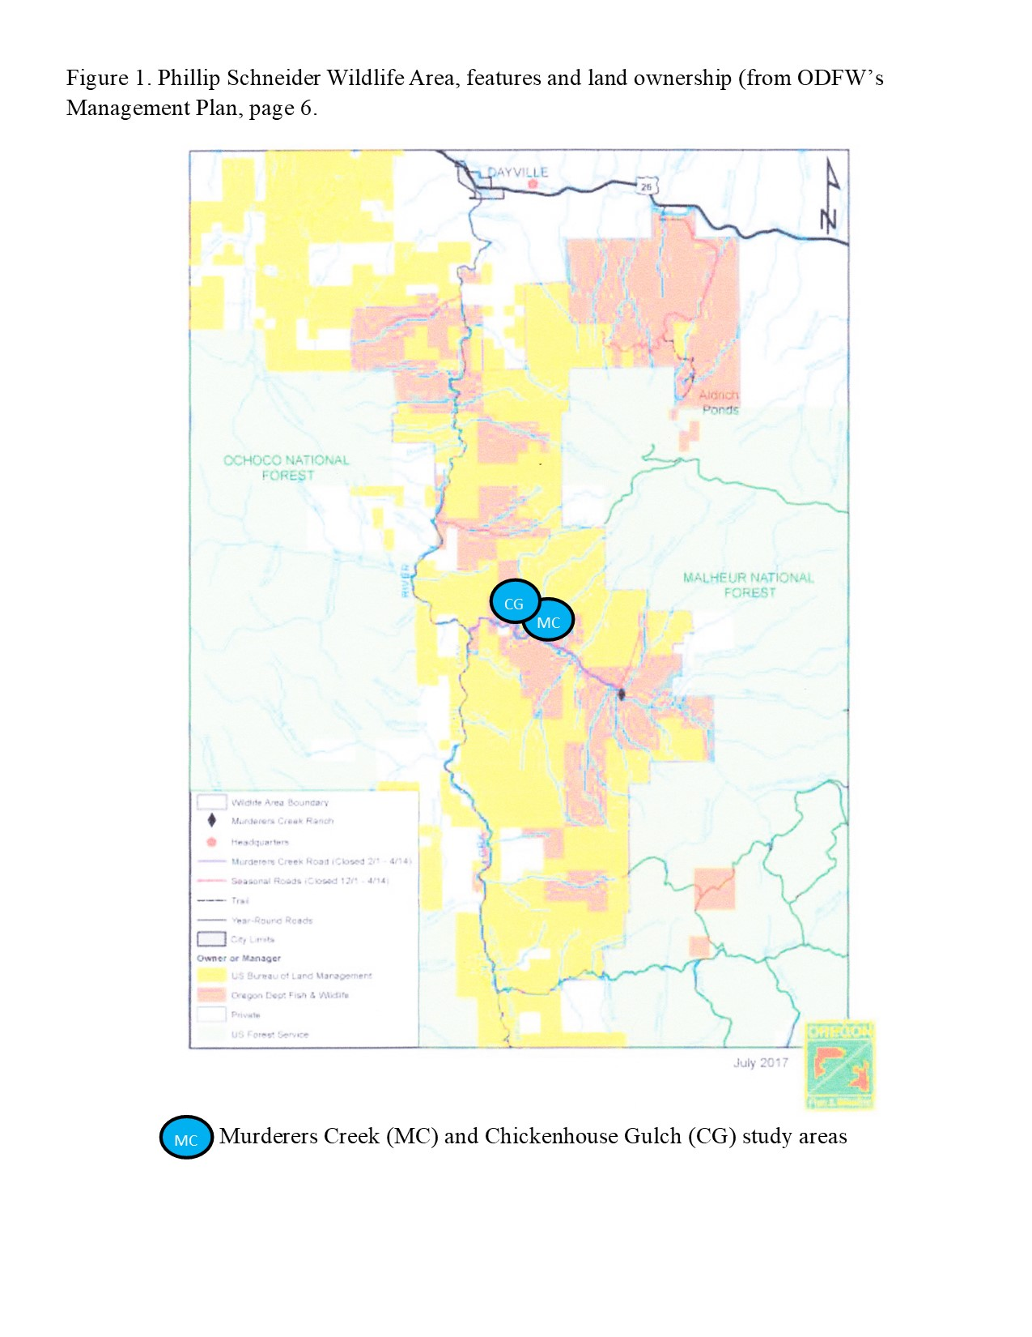Figure 1. Phillip Schneider Wildlife Area, features and land ownership (from ODFW’s Management Plan, page 6.)

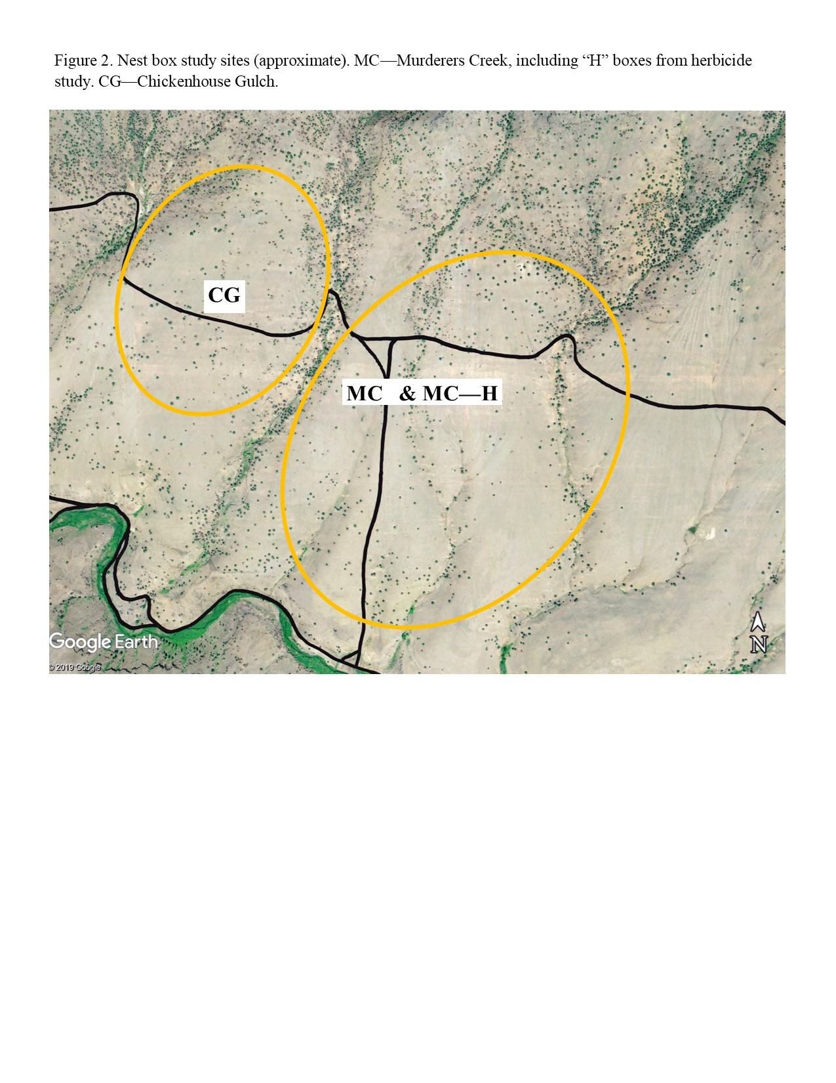Figure 2. Nest box study sites (approximate locations). MC – Murderers Creek, including “H” boxes from herbicide study. CG – Chickenhouse Gulch.

Figure 3-A, 3-B, and 3-C. Nest box numbers and approximate locations and topographic relief. These maps are for field use in finding boxes, assisted by aerial photos and GPS.

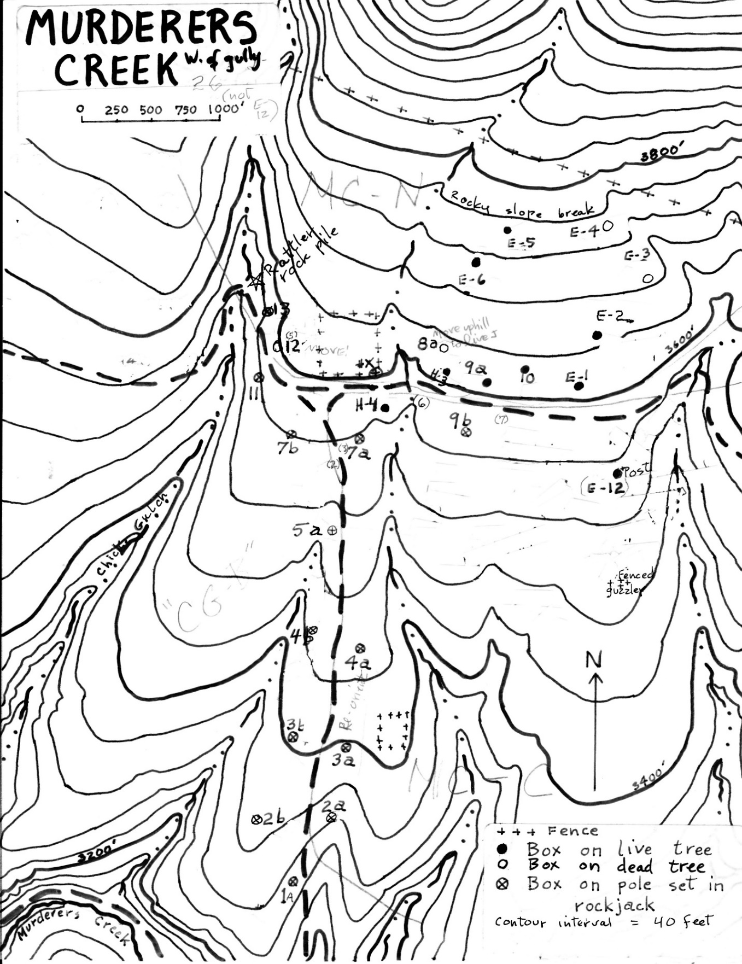

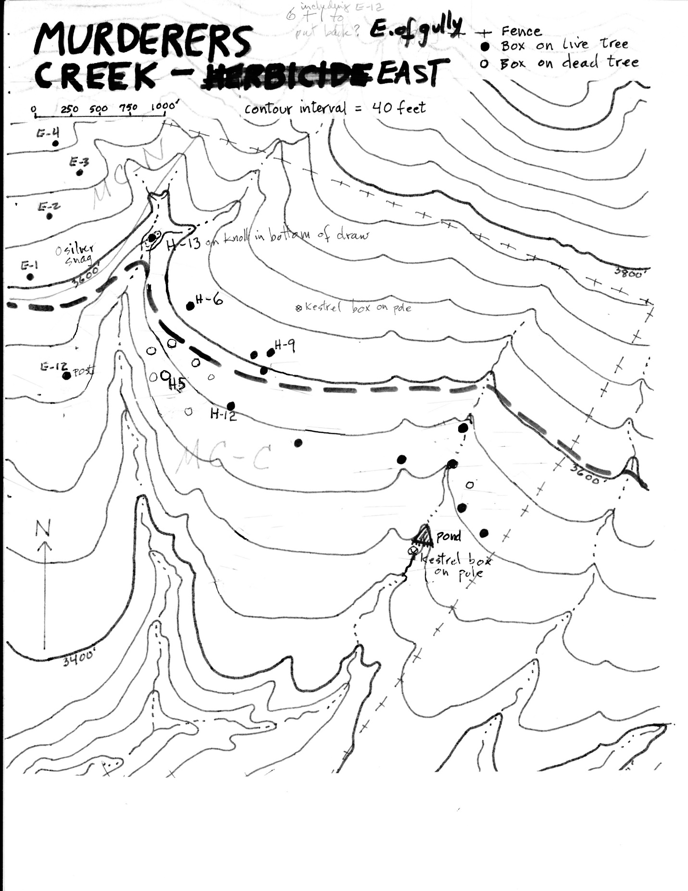

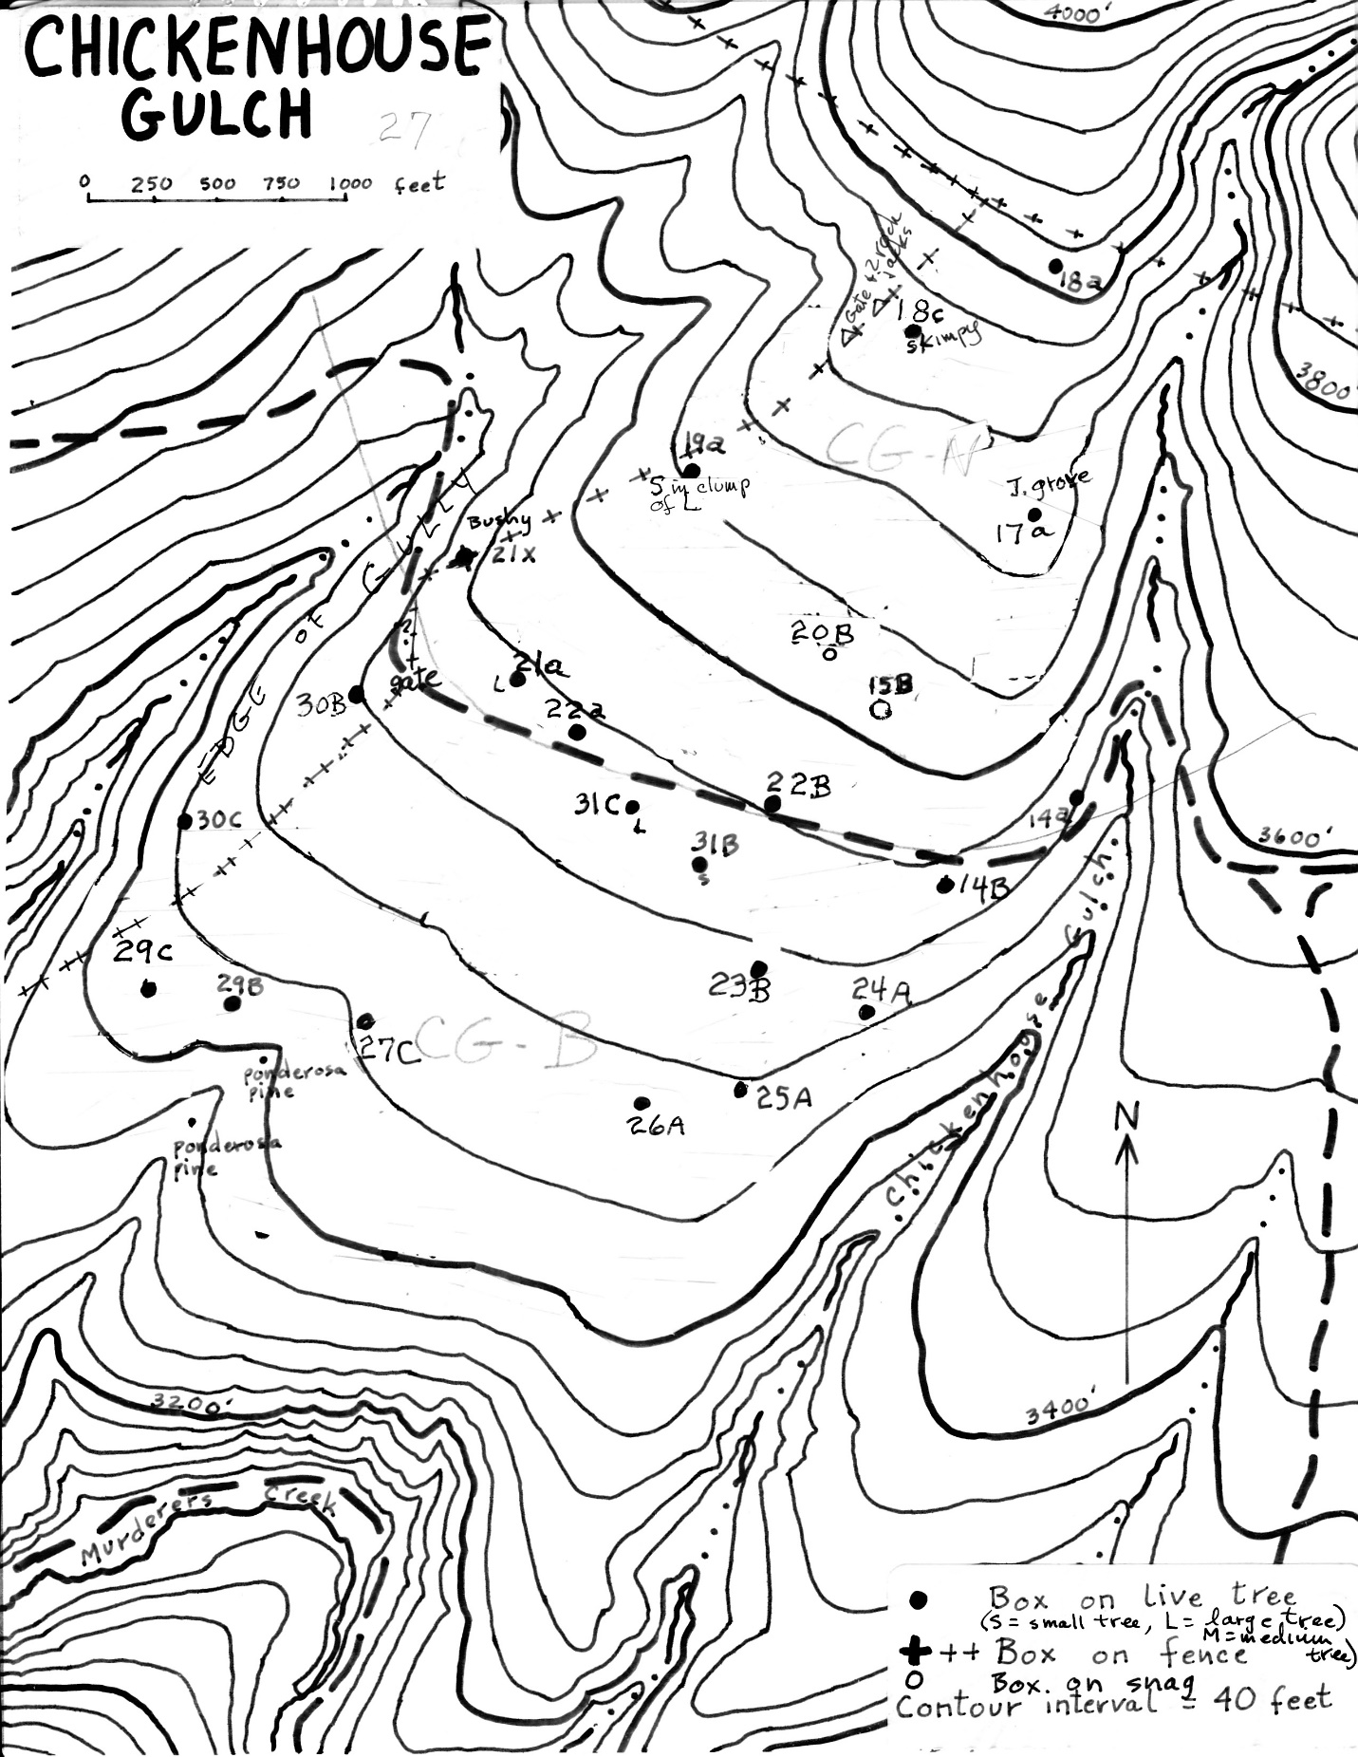

**Table 1. USE OF BLUEBIRD NEST BOXES AT THE PHILLIP SCHNEIDER WILDLIFE AREA**

**1990 to 2019**

|  |  |  |  |  |  |  |  |  |  |  |  |  |  |  |  |
| --- | --- | --- | --- | --- | --- | --- | --- | --- | --- | --- | --- | --- | --- | --- | --- |
|  | **1990** | **1991** | **1992** | **1993** | **1994** | **1995** | **1996** | **1997** | **1998** | **1999** | **2000** | **2001** | **2002** | **2003** | **2004** |
| **Nest boxes available** | **70** | **70** | **70** | **70** | **69** | **69** | **68** | **67** | **82** | **75** | **77** | **76** | **76** | **73** | **71** |
| **Visits / year** | **5** | **5** | **6** | **5** | **5** | **4** | **3** | **7** | **3** | **1** | **4** | **1** | **1** | **1** | **1** |
| **Nest boxes used\*** | **9**  **13%** | **26**  **37%** | **24**  **34%** | **24**  **34%** | **36**  **52%** | **42**  **61%** | **37**  **54%** | **35**  **52%** | **43**  **52%** | **38**  **51%** | **59**  **77%** | **36**  **47%** | **33**  **43%** | **31**  **42%** | **31**  **44%** |
| **W. Bluebird fledged nests** | **6** | **10** | **12** | **17** | **18** | **12** | **14** | **8** | **5** | **-** | **6** | **-** | **-** | **1** | **-** |
| **M. Bluebirds fledged nests** | **2** | **5** | **2** | **1** | **5** | **1** | **2** | **9** | **9** | **-** | **34** | **-** | **-** | **-** | **-** |
| **All bluebirds fledged nests** ** | **9** | **17** | **17** | **20** | **37** | **16** | **26** | **17** | **27** | **32** | **41** | **29** | **17** | **25** | **23** |
| **A-t. Flycatch. fledged nests** |  |  |  |  |  |  |  |  |  |  |  |  | **2** |  |  |
| **Tree Swallow fledged nests** | **1** |  |  | **1** |  | **1** |  |  |  |  |  |  |  |  |  |
| **Mt. Chickadee fledged nests** |  |  |  |  |  | **1** | **1** |  |  |  |  |  |  |  |  |

* Includes all bird species. Includes only boxes with at least one nest with at least one egg.

** Includes Western and Mountain Bluebirds as well as bluebirds not identified to species. Many unidentified

nests were early ones, which were likely Mountain Bluebird.

|  |  |  |  |  |  |  |  |  |  |  |  |  |  |  |  |
| --- | --- | --- | --- | --- | --- | --- | --- | --- | --- | --- | --- | --- | --- | --- | --- |
|  | **2005** | **2006** | **2007** | **2008** | **2009** | **2010** | **2011** | **2012** | **2013** | **2014** | **2015** | **2016** | **2017** | **2018** | **2019** |
| **Nest boxes available** | **63** | **65** | **63** | **62** | **65** | **65** | **-** | **62**  **(& 1 small)** | **65**  **(& 6 small)** | **58**  **(& 1 small)** | **54** | **-** | **51** | **50**  **(& 1 small)** | **51** |
| **Visits / year** | **1** | **1** | **1** | **1** | **1** | **1** | **0** | **1** | **1** | **1** | **1** | **0** | **1** | **1 \*\*\*\*** | **1** |
| **Nest boxes used\*** | **36**  **57%** | **41**  **63%** | **29**  **46%** | **29**  **47%** | **23**  **35%** | **28**  **43%** | **(47)\*\*\***  **(76%)** | | **32**  **49%** | **31**  **53%** | **31**  **57%** | **(35)\*\*\***  **(69%)** | | **32**  **64%** | **25**  **49%** |
| **W. Bluebirds fledged nests** | **-** | **1** | **1** | **-** | **-** | **-** | **-** | | **1** | **1** | **1** | **1** | | **1 & 1?** | **1** |
| **M. Bluebirds fledged nests** | **-** | **-** | **1** | **-** | **-** | **-** | **3** | | **1** | **-** | **1** | **2** | | **16 & 5?** | **1** |
| **All bluebirds fledged nests**\*\* | **27** | **25** | **20** | **21** | **17** | **14** | **46** | | **25** | **20** | **25** | **37** | | **23 & 6?** | **21** |
| **A-t. Flycatch.. fledged nests** | **1** |  | **1** | **1** | **1** | **1** | **1** | |  | **1** |  | **2** | | **1** |  |
| **Tree Swallow fledged nests** | **1** |  |  |  |  | **1** | **1** | |  |  |  |  | |  |  |
| **Mt. Chickadee fledged nests** |  |  | **1** |  | **1** |  | **2** | | **1** | **1** |  | **1** | |  | **1** |
| **House Wren fledged nests** |  |  |  |  |  |  |  | |  | **1** |  |  | |  | **1** |

*** Combined totals for the 2 years.

**** In 2018, one visit was made in May. The totals for this year are estimates from 2019.

Disregarding the first year, the first 14 years averaged 35 of 72 boxes used (>1 nest with >1 egg) by all birds, or 49% of the boxes available each year. For the last 15 years, the average was 28 of 60 boxes used, or 47%.